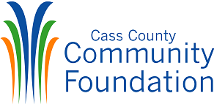
2025
APPLICATION FORM “A”

_____________________________________________________________FIRST NAME MIDDLE LAST

_____________________________________________________________
ADDRESS

_____________________________________________________________
CITY COUNTY STATE ZIP

PHONE # _______________ ALTERNATE PHONE #_________________

E-MAIL ADDRESS_____________________________________________

NAME OF HIGH SCHOOL ATTENDING__________________________

HIGH SCHOOL PHONE NUMBER _____________________________________

PRINCIPAL’S NAME __________________________________________________

PARENTS’/GUARDIANS’ NAMES________________________________

________________________________________________________________________

ADDRESS TELEPHONE CELL OR WORK PHONE

_______________________________________________________________________

CITY COUNTY STATE ZIP

2025
APPLICATION FORM “B”

Date of Birth ________________________________________________________________________________________________________

Year you will be entering college ___________________________

Intended majors____________________________________________

Intended minors ___________________________________________________

Anticipated High School Graduation Date__________________

What is your first college choice?
Have you applied? Yes No

What is your second college choice?
Have you applied? Yes No

Have you been accepted to any colleges at this time?
Yes No
If so, where?

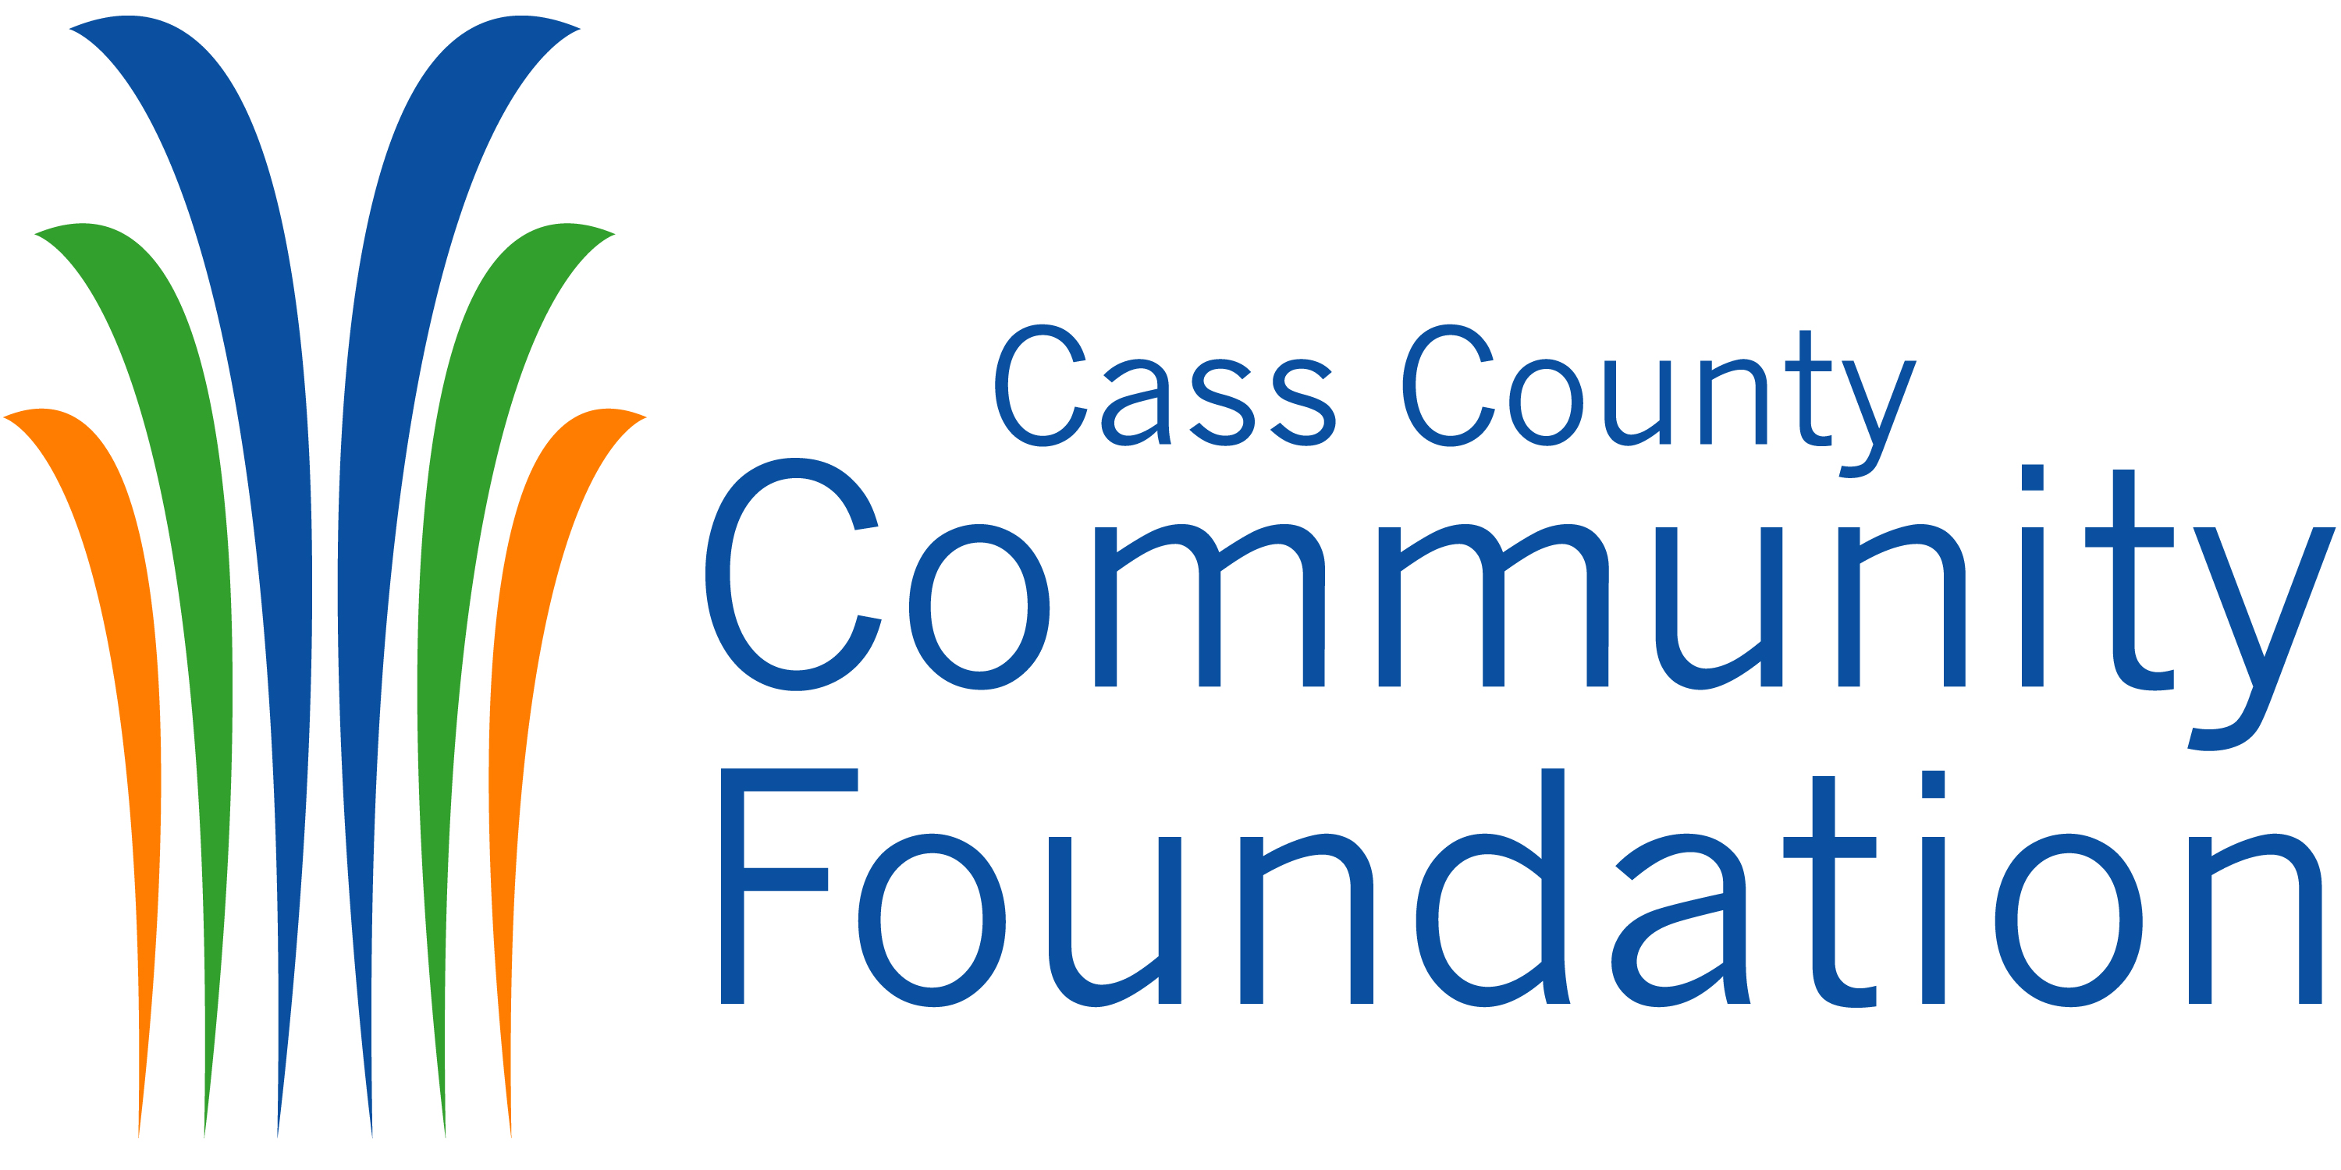

STATEMENT SIGNATURE PAGE

The Cass County Lilly Endowment Community Scholarship Program requires
the following statements must be signed by each applicant:

- If I receive this scholarship, it is my intent to pursue four years of undergraduate study on a full-time basis leading to a baccalaureate degree at an Indiana College.

- I understand that the total maximum amount of my scholarship is calculated on the basis of my chosen college’s tuition and required fees beginning with the 2025-2026 school year.

- To assist with and to avoid late fees in the processing of my scholarship payments each semester or quarter, I will forward immediately to the Cass County Community Foundation all invoices received for tuition and any eligible fees that may be covered by my scholarship.
- I understand that the special allocation provided to me is to be used to pay
required books and required equipment for my courses of instruction. I will
personally keep receipts and other documentation to verify that the special
allocation was used only for this intended purpose and will provide those receipts
and documents to Independent Colleges of Indiana upon request. If the amount
remaining exceeds $25, I will return to Independent Colleges of Indiana the
balance of the special allocation at the end of each school year.

- I agree to notify Independent Colleges of Indiana of any scholarship awards I may receive for tuition or required fees from a source other than the Lilly Endowment Community Scholarship.

- I will keep the Cass County Community Foundation appraised annually by June 1st of my enrollment and academic status during college, by completing and returning any surveys or forms as may be provided by the community foundation.

- Upon graduation, I will keep the Cass County Community Foundation appraised annually by June 1st of my education and/or employment status for at least ten years after graduation, by completing and returning an alumni survey or other forms as may be provided by the community foundation.

Agreed to by: ___________________________________________________
Printed Name of Scholar
____________________________________________________
Signature of Scholar Date

